**Creating & Printing Dictionary using Key-Value Pair**

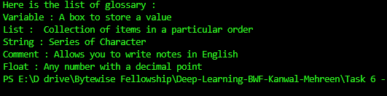

**Looping using dict.items()**

**Looping with Conditions**

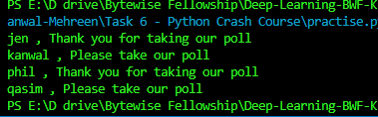

**Nested Loops**

